**Memorandum**

DATE: 29 January 2016

TO: Rich Marovich, Roland Sanford, and Chris Lee, Solano County Water

Agency (SCWA)

FROM: Tim Salamunovich, Normandeau Associates

RE: Results of October 2015 lower Putah Creek fish surveys

Normandeau Associates (formerly Thomas R. Payne & Associates) has been sampling the fish fauna of lower Putah Creek using tote barge electrofishing since August 1991. Students from the University of California at Davis (UCD) have been regularly sampling the creek near campus using a combination of boat/backpack electrofishing, seining, and gill netting each fall since 1978. Following the May 2000 Putah Creek Water Accord, Normandeau continued surveying multiple sites along the creek each October as part of an annual fish monitoring program under the aegis of the Lower Putah Creek Coordinating Committee. A database containing all the raw data (individual fish lengths and weight data by site and survey date) for the entire period of record is regularly updated and managed by SCWA. The data through 2008 was treated in a recent scientific publication (Kiernan et al. 2012). This paper demonstrated the recovery of native fishes in the upper 12.5 miles of the creek (upstream of Pedrick Road [County Road 98]) following the native fish rearing and spawning flows instituted under the Water Accord. Normandeau crews sampled nine sites along 19 miles of the lower creek between Putah Diversion Dam (PDD) and Mace Boulevard (County Road 104; Figure 1) on 13-15 October 2015. Two additional sites near the UCD campus (Figure 1) were sampled on 24 October 2015 by a UCD fisheries class and the results were generously provided for review. This memo report will present the results of these two most recent sampling efforts.

The objective of the Fall 2015 electrofishing survey was to determine the distribution and relative abundance of fish populations in lower Putah Creek between Putah Diversion Dam and Mace Boulevard [Yolo County Road 104] (Figure 1). Normandeau crews conducted sampling at nine locations on 13-15 October 2015 using a Smith-Root gas powered generator and pulsator (model 2.5 GPP) operated out of a small pram. Two biologists wading alongside the pram used two six-foot long electrofishing probes to attract and stun fish. Two additional biologists netted and captured stunned fish and transferred them to several five-gallon aeration buckets located in the front of the pram. A fifth person rowed or pulled the pram and was primarily responsible for shutting off the electric current in the event of a mishap. Sampling effort was emphasized along the margins of the creek around instream cover and overhead vegetation, but additional effort was still allocated to open water portions of the creek. Total effort expended at each site was made approximately equal by a combination of measurements of stream area and shocking seconds. All stunned fish were netted and held in buckets equipped with small bait-bucket aerators and captured fish were periodically transferred to a live

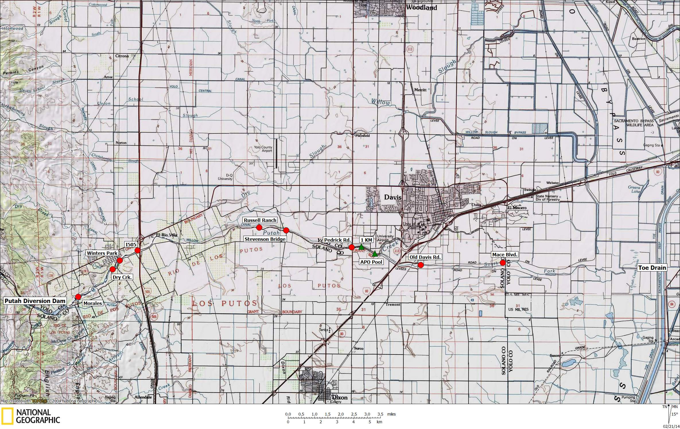

Figure 1. Map showing the nine Normandeau sample sites (red circles) and two UCD sample sites (green triangles) surveyed along

lower Putah Creek in October 2015.

cart until the completion of sampling, at which time the fish were identified and measured to nearest millimeter using either fork length (FL) or total length (TL). A sub-sample of the catch was also weighed to nearest 0.1 gram to determine condition factors (length-weight ratios) prior to release. All rainbow trout captured during the surveys were weighed. The trout were anesthetized in weak CO2 solution prior to handling to reduce movement and injury during the measurement and weighing process. After handling, all trout were allowed to fully regain mobility in a aeration recovery bucket prior to their release.

Two additional sites (the Alpha Phi Omega [APO] pool and the 1 Kilometer [1 KM] sites) were sampled by students of Dr. Peter Moyle’s Wildlife, Fish, & Conservation Biology class on 24 October 2015 (Figure 1). UCD sampling used a variety of capture gear including beach seines, gillnets, and boat shocker (equipped with a 5.0 GPP) at the APO Site; and backpack electrofishers at the 1 KM Site. All fish were identified, enumerated, and most were measured to standard length (SL) or FL or TL and released.

Figure 2. Mean daily discharge released into lower Putah Creek at the Putah Diversion

Dam during the 2015 Water Year.

The 2015 Water Year, which ended two weeks prior to the sampling, was classified as a critical water year for the Sacramento basin according the Sacramento Valley 40-30-30 Hydrologic Classification Index (DWR California Data Exchange Center). Eight of the last nine water years in the Sacramento Valley have been classified as below normal, dry, or critical. The mean daily flow in lower Putah Creek (as measured at the Putah Diversion Dam release) during the period of fish spawning and rearing for the year prior to sampling is shown in Figure 2.

There were no extended periods of high flows during the 2015 water year (Table 1). The maximum daily flow for the water year immediately prior to sampling was 205 cfs cubic feet per second (cfs) and was the result of early February storm event. The remaining higher flow events were the result of managed releases into the lower creek to accommodate salmon migration in the late fall and native fish spawning in the early spring. Despite the critically dry water year, the mean dam release to the lower creek for the 2015 Water Year was 53.4 cfs, and the dam release never fell below 37 cfs during the water year.

Table 1. Number of days that mean daily releases from Putah Diversion Dam exceeded

certain values during the 2015 water year (1 October 2014–30 September

2015) immediately prior to the October 2015 surveys. Data from USBR Mid-

Pacific Region, Central Valley Operations Website.

|  |  |
| --- | --- |
| Exceedance (cubic feet per second) | Number of Days |
|  |  |
| ≥ 500 cfs | 0 |
| ≥ 300 cfs | 0 |
| ≥ 250 cfs | 0 |
| ≥ 200 cfs | 1 |
| ≥ 150 cfs | 1 |
| ≥ 100 cfs | 3 |
| ≥ 50 cfs | 149 |
| ≥ 35 cfs | 365 |

As specified in the Water Accord, flows in Putah Creek at Interstate 80 Bridge near Davis are monitored and dam releases to lower creek are adjusted to maintain minimum flows of at least 5 cfs (or higher) throughout the year (Table 2). This flow requirement ensures maintenance of a live stream throughout 15.5 miles of the lower basin, even during dry and critically dry water years. In addition, the Accord includes supplemental flow releases into the lower basin to attract anadromous salmonids in the fall and to promote native fish spawning in the spring (Figure 2).

Table 2. Mean daily flow requirements for Putah Creek at Interstate 80.

|  |  |
| --- | --- |
| Month | Minimum Flow Requirement (cfs) |
|  |  |
| October | 5 |
| November | 10 |
| December | 10 |
| January | 15 |
| February | 15 |
| March | 25 |
| April | 30 |
| May | 20 |
| June | 15 |
| July | 15 |
| August | 10 |
| September | 5 |

Stream flow in the lower basin during the October 2015 Normandeau fish surveys survey varied by site and ranged from 40 cfs at the Putah Diversion Dam to about 8 cfs at the sites downstream of the I-80 Bridge (Table 3). Flows in the lower basin during the late October UCD surveys were 7 to 8 cfs.

Table 3. River mile location, sample date, survey time, stream flow, water temperature,

conductivity, and salinity at time of survey for the eleven lower Putah Creek

study sites during the October 2015 fish monitoring surveys. River mile

notation is based upon USBR convention where RM 0.0 is point where creek

enters the Yolo Bypass.

|  |  |  |  |  |  |  |  |  |
| --- | --- | --- | --- | --- | --- | --- | --- | --- |
| Site | River Mile | Date | Time | Flow 1/  (cfs) | Temp (°C) | DO (mg/L) | Cond  μS/cm | Salinity  ppt |
|  |  |  |  |  |  |  |  |  |
| Putah Diversion Dam | 22.6 | 10/15/15 | 1717 | 39.7 | 15.8 | --- | 299 | 0.2 |
| Dry Creek confluence | 20.3 | 10/15/15 | 1324 | 32.7 | 16.8 | --- | 304 | 0.2 |
| Winters Park (Car Bridge) | 19.7 | 10/15/15 | 0918 | 31.7 | 16.1 | --- | 303 | 0.2 |
| Interstate 505 Bridge (I505) | 18.9 | 10/14/15 | 1620 | 34.0 | 17.9 | 9.14 | 313 | 0.2 |
| Russell Ranch | 13.7 | 10/14/15 | 1314 | 15.5 | 18.3 | 8.83 | 317 | 0.2 |
| Stevenson Road Bridge | 12.8 | 10/14/15 | 1005 | 15.9 | 18.4 | 8.57 | 318 | 0.2 |
| Pedrick Road Bridge | 9.9 | 10/13/15 | 1605 | 9.3 | 18.7 | 8.83 | 325 | 0.2 |
| 1 Kilometer Site (1 KM) | 9.4 | 10/24/15 | 1030 | 8.2 | 15.7 | 8.30 | 323 | --- |
| Alpha Phi Omega (APO) Pool | 9.1 | 10/24/15 | 1030 | 7.2 | --- | --- | --- | --- |
| Old Davis Road Bridge | 7.2 | 10/13/15 | 1315 | 7.7 | 20.0 | 8.37 | 475 | 0.3 |
| Mace Boulevard Bridge | 3.8 | 10/13/15 | 1030 | 7.6 | 18.2 | 3.63 | 468 | 0.3 |

1/ Flow data from Solano County Water Agency

Water temperatures measured during the October surveys varied by site as a function of both the time of day and the distance downstream of the Putah Diversion Dam release point (Table 3). Water conductivity (a measure of total dissolved solids) and salinity tended to increase in relation to the distance downstream of the Putah Diversion Dam. Except for the most downstream Mace Boulevard site, dissolved oxygen levels were

Table 4. Capture data for the October 2015 fish monitoring surveys on lower Putah Creek.



relatively high and exceeded 8 mg/L at the remaining sites sampled. No water quality data was recorded at the APO Pool Site during the UC Davis surveys and the dissolved oxygen meter malfunctioned on 15 October and no readings were taken at sites sampled on that day.

The October 2015 fish surveys of eleven lower Putah Creek sites captured a total of 2,546 fish representing 20 species (Table 4). Sacramento pikeminnow (*Ptychocheilus grandis*) was the most abundant species, making up over 31 percent of the total catch. The next most common fishes among the catch were largemouth bass (*Micropterus salmoides*) and Sacramento sucker (*Catostomus occidentalis*) with each contributing about 16 percent of the total catch and tule perch (*Hysterocarpus traskii*) another 12 percent. Riffle sculpin (*Cottus gulosus*) and bluegill (*Lepomis macrochirus*) each made up about 5 percent of the catch. None of the remaining fourteen species made up more than 3.3 percent of the total catch, with seven of those species each contributing less than 1 percent.

Figure 3. Number of native and exotic fish captured at each of the lower Putah Creek study sites

during the October 2015 fish surveys.

Of the total fish captured in the fall 2015 survey, 71.6 percent (1,823 fish from 8 species) were natives, while 28.4 percent (723 fish from 12 species) were non-native, or exotic fishes (Table 4, Figure 3). The overall spatial distribution of fishes from the October 2015 survey remains similar to recent surveys and continues to demonstrate that lower Putah Creek supports a highly diverse fish fauna. The results also show that, despite four consecutive and worsening water years (WY2012 below normal; WY2013 dry; WY2014 critical; WY 2015 critical) and the lack of extended periods of high flow over this period, native fish continue to dominate the 12.7 miles of the lower basin between the Putah Diversion Dam at Winters and the Pedrick Road Bridge Site near Davis (Table 4; Figures 3 and 4).

Figure 4. Percentage of native and exotic fish captured at each of the lower Putah Creek study

sites during the October 2015 fish surveys.

The catch data show that native fish dominated the catch in the upper 12.7 miles of the study area between the Putah Diversion Dam and Pedrick Bridge (Table 4). In fact, only three non-native fish were captured in the upper 3.0 miles of the study area and native fish made up 96 percent of the total catch at the seven study sites located in the upper 12.7 miles of the study area at and upstream of the Pedrick Road site (Figure 4).

At the 1 KM Site, which is located about 0.5 miles downstream of Pedrick Road, non-native fish abundance had increased to almost 56 percent of the total catch and that fraction of exotic fish increased again just downstream at the APO Pool site where non-native now dominated the local fish populations and contributed 90 percent of the total catch. At the two remaining downstream sites (Old Davis Road and Mace Boulevard) non-native made up 100 percent and 90 percent of the total catches, respectively (Figure 4).

The greatest change noted in 2015 from 2014 fall fish surveys occurred at the 1 KM Site. In the Fall 2014 survey, native fish made up over 82 percent of the fish assemblage, while in the Fall 2015 they made up only about 44 percent of the total catch. This reversal of native fish domination of the fish assemblage at the 1 KM Site in was due to the large declines in the catch of Sacramento pikeminnow and prickly sculpin (*Cottus asper*) in October 2015 compared to the previous year. This represents a 72 percent reduction in abundance of pikeminnow and a 96 percent reduction in the abundance of prickly sculpin at this site between the two annual surveys.

Of the native species captured during the October survey, some species, such as rainbow trout (*Oncorhynchus mykiss*) and threespine stickleback (*Gasterosteus aculeatus*) were limited to the upper half of the study area (Table 4). The native pikeminnow, sucker, prickly sculpin, and tule perch were more widely distributed, and were found throughout the lower basin. Similar to the last two previous years, rainbow trout were captured at all five sites between the PDD and Russell Ranch. The capture of rainbow trout at the Russell Ranch site in the 2013, 2014, and 2015 surveys are the only times any salmonid have been captured at this site located about nine miles below the PDD over fourteen sampling events conducted over the last 16 years. Prior to 2013 the farthest downstream site where rainbow trout have been consistently captured was the I505 bridge site, which is located about 5.3 miles upstream of the Russell Ranch area. Upstream habitat improvements (e.g. removal of the Winters Percolation Dam and the Winters Park channel restoration) may be aiding the widening distribution of coldwater dependent salmonids, through the downstream extension of cool water. Future monitoring may provide additional evidence about whether trout are able to become part of the regular fish fauna found at Russell Ranch and other sites downstream.

The spatial distribution of exotic fishes also varied by species (Table 4). Black bullhead (*Ameiurus melas*), white catfish (*Ameiurus catus*) and spotted bass (*Micropterus punctulatus*) were limited to single locations in the lower basin. Largemouth bass (*Micropterus salmoides*) and green sunfish (*Lepomis cyanellus*) were widely distributed in the late Fall 2015 and were captured at ten and six of the sites, respectively. While largemouth bass had a relatively wide distribution, their highest densities occurred along the lower 5.5 miles of the survey area, at the APO pool and downstream (Table 4).

One noteworthy trend noted in the 2015 sampling was the continued decline in the exotic “panfish” populations that were first observed in the 2010 surveys. This group is comprised of the smaller sunfish of the genus *Lepomis* and includes green sunfish, bluegill, redear sunfish (*L. microlophus*), warmouth (*L. gulosus*), pumpkinseed (*L. gibbossus*) and various hybrids forms. Prior to 2010, green sunfish and bluegills were among the most common species of fish found in lower Putah Creek. In the six fall surveys conducted between 2003-2008 “lepomids” made up 28.1 percent of the total fish captures, and averaged 1,462 lepomids per survey. In the five complete, basin-wide surveys between 2010 and 2015, “lepomids” had declined to only 5.1 percent of the total captured fish, and averaged only 179 “lepomids” per survey. This is a decline of about 88 percent in “lepomids”/survey between the 2003-2008 and the 2010-2015 survey periods. The scarcity of “lepomids” in 2012 through 2015 is especially surprising since these three water years were all classified as below normal (or less) in the Sacramento Valley with few periods of natural high flows, that might disrupt sunfish spawning. These non-native sunfish species usually thrive during these low and warm water conditions. Future surveys may show if these exotic sunfish abundances rebound to former levels, or perhaps this suite of species is finding conditions in lower Putah Creek no longer suitable to sustain abundant population levels.

Despite the recent declines in the smaller “lepomid” sunfish populations in lower Putah Creek, the larger centrarchids, such as the “micropterid” basses or black bass (especially largemouth bass) still remain abundant, especially in the lower 14 miles of the creek (Table 4). In the six surveys conducted 2003-2008, bass (i.e., largemouth, smallmouth, and spotted bass) made up 6.8 percent of the total fish captures, and averaged 353 black bass per fall survey. In the five complete basin-wide surveys conducted from 2010-2015, black bass have made up 11.6 percent of the captures and have average 407 bass per survey. This is an increase of 15 percent in black bass per survey between the 2003-2008 and the 2010-2015 survey periods. So, while the smaller sunfish species have exhibited a decline in recent years, the basses have remained a dominant fish, especially in the downstream survey areas. Perhaps some species interactions are operating where black bass are helping to suppress the smaller sunfish in the lower basin through predation. It is unknown how the presence of black bass in the lower basin may impact the recently-resurgent Chinook salmon (*O. tshawytscha*) fry outmigration in the winter and spring. In the mid-November through December of 2015 an estimated 500-700 adult Chinook salmon were thought to have migrated and spawned in lower Putah Creek, with redds noted from the Putah Diversion Dam downstream to Mace Boulevard bridge area (Peter Moyle, Ken Davis, personal communication).

The 2015 survey included the Winters Park site, which represents a relatively new sample site along lower Putah Creek that has been surveyed only since 2012. In November 2011, a channel realignment project (Winters Park Project) was completed along a 3,700 foot-long section of Putah Creek. This project was designed to restore natural channel form and function, enhance habitat of native species and improve public access in a reach that had been mined extensively for gravel and otherwise enlarged, straightened and dammed for flood conveyance and seasonal water storage.  This project included removing a long-standing low flow barrier (Winters Percolation Dam), reconfiguring the creek channel to a narrower and shallower meandering form, restoring the functional floodplain, and replanting native plant species along the riparian corridor. Three existing riffles were augmented and 14 new riffles were created at 200 foot intervals by importing 2,000 tons of salmon spawning gravel mix (Rich Marovich, personal communication). It was anticipated that this channel realignment project would eliminate the extensive areas of large deep pool habitat that acted as a heat sink and harbored large predatory non-native basses, and instead create hydraulically diverse and cooler water habitat that would benefit native fish, including salmonids. Fish salvage and relocation efforts conducted in the project area in September 2011 (prior to construction) included only one rainbow trout in this section of Putah Creek (Peter Moyle, personal communication).

Since channel restoration, rainbow trout have regularly been captured in this area. Twenty rainbow trout were captured at the Winters Park site in October 2012, eight rainbow trout were captured in October 2013, nine rainbow trout were captured in October 2014, and eleven were captured in October 2015 (Photograph 1). During all these surveys, the trout were captured in the turbulent water immediately below the boulder weirs or in a short shallow riffle near the upstream end of the site (Photograph 2). The rainbow trout appear to be using the recently restored channel area and appear to be present in larger numbers than were present prior to the channel realignment.

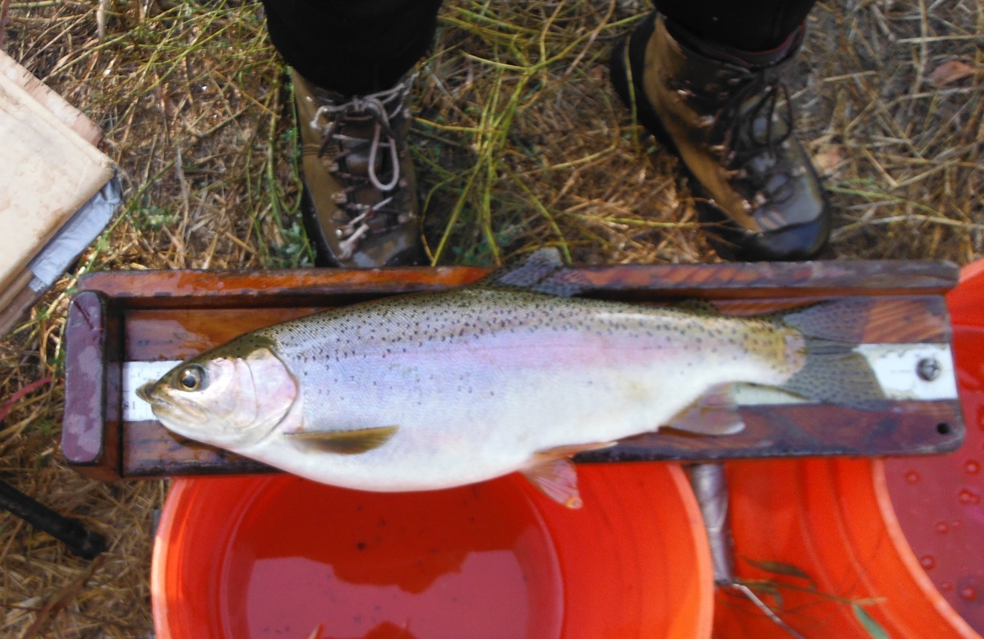

Photograph1 . Large rainbow trout (382 mm FL [15 inch] / 830.2 gram [1.8 pound]) captured at

Winters Putah Creek Park upper weir, 15 October 2015

In conclusion, despite continuing dry water years and limited periods of extended high flow, the native fish populations continue to thrive in the thirteen miles of Putah Creek from the Putah Diversion Dam to downstream of Pedrick Road. Continued fall fish monitoring should indicate how the fish populations respond to the changing water year types and the continuing benefits of the Settlement Agreement flow regime.

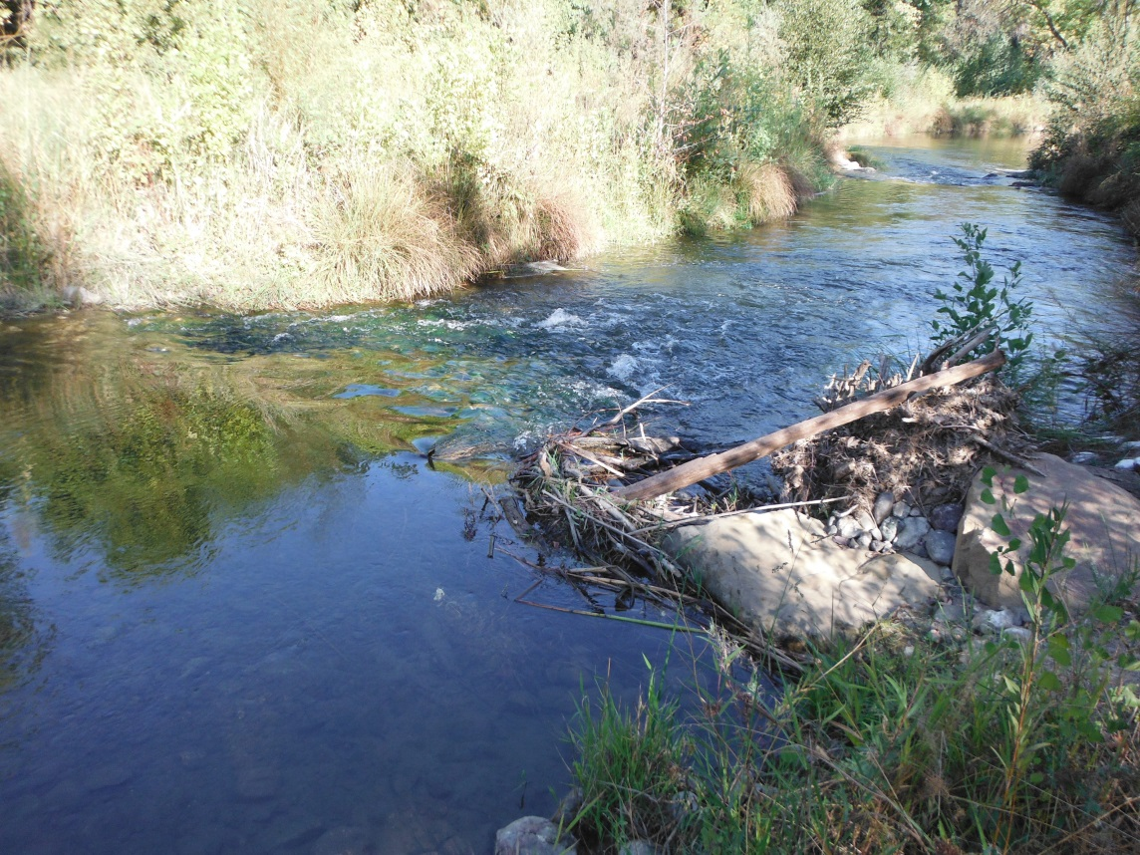

Photograph 2. Top of riffle looking downstream to upper boulder weir at Winters Putah Creek

Park, 15 October 2015 (31.7 cfs).

Literature Cited

Kiernan, J.D., P.B. Moyle, and P.K. Crain. 2012. Restoring native fish assemblages to a regulated California stream using the natural flow regime concept. Ecological Applications 22:1472-1482.